CENWP-OD-B 08/03/12

MEMORANDUM FOR THE RECORD

SUBJECT: 12BON31 Lamprey mortality at Bonneville’s Washington Shore Adult Fish Facility (AFF).

On 03 August NOAA researchers contacted Project Fisheries to report a dead adult Pacific lamprey. In addition, CRITFC researchers reported a dead Chinook. The lamprey was found at 0715 in the Port 2 lamprey trap in the AFF fishway, and was not a recent mortality. The Chinook was found in the holding tank trash rack and was in an advanced state of decomposition. Information for the lamprey and Chinook is provided below:
- Species – Pacific lamprey (Entosphenus tridentatus) and Chinook (Oncorhynchus tshawytscha).
- Origin – Unknown.
- Length – 61.5 cm (lamprey) and 66.5 cm (Chinook).
- Marks and tags – None.
- Marks and Injuries found on carcass – No notable marks or injuries.
- Cause and Time of Death – Unknown. Lamprey discovered at 0715 hours and Chinook at 1030 hours on 03 August, 2012.
- Future and Preventative Measures – Not applicable at this time.

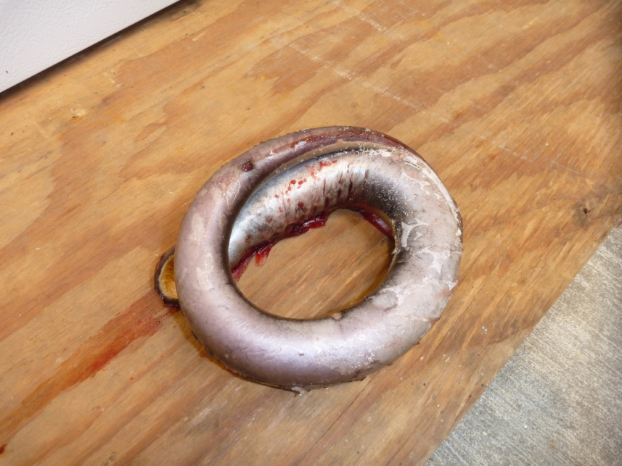
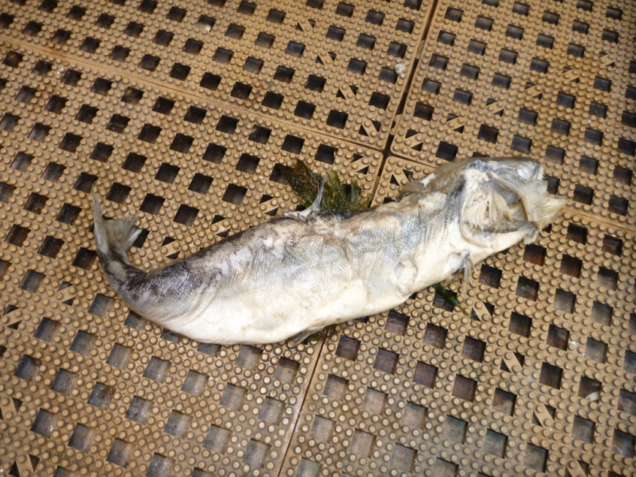

Sincerely,
Bonneville Project Fisheries

